

MEMBER LEGISLATIVE TOOL KIT

Table of Contents
I | Advocacy: Why does it matter?  - Illinois Financial Aid Profile (UNDG/GRAD)  - Connecting with your Legislative Liaison
II | How to use the Illinois General Assembly website  - Website navigation  - Searching the Illinois Watch List  - Responding to Legislation
III | How a Bill Becomes a Law  - The Legislative Calendar Cycle
IV | Financial Aid 101 for Staffers  - What is the role of the Staffer  - What is the role of a Financial Aid Administrator
V | Advocating through Negotiated Rulemaking
VI | Resources  - NASFAA State Advocacy Toolkit  - AACROA Advocacy Center

Advocacy: Why does it matter?

What is Advocacy? “The act or process of supporting a cause or proposal; the act or process of advocating something”

Your Voice Matters! You do not need to be in Washington, D.C., or even Springfield, Illinois, to be an effective advocate for student financial aid. Once you have defined key issues of importance to your students and your institution, these will serve as a framework to help you consider the following questions that will drive your advocacy efforts:
What is the mission of your organization?
- What is important to your state, the ILASFAA association, and your students?
- What major issues are at hand in Illinois? Is there a particular topic or piece of legislation that continues to surface?
- Is there an issue that is a common frustration to students and families?
- Are there any issues causing undue hardship for students, or administratively burdensome for financial aid administrators?

The next step is to act on behalf of the students, institution, and association. Identify specific points or values that you want to communicate. Focus on the most important aspects of the topic; do not include too many details. Legislators and staffers are generalists and consider financial aid administrators to be the experts.

YOU are an advocate for students at your institution. According to the NASFAA “What Financial Aid Administrators Do” graphic, aid administrators:

- Offer feedback from an institutional perspective on student aid legislation and proposals
- Provide financial aid success stories of students from your state or district
- Explain the financial aid needs and challenges of students in your state or district
- Supply statistics detailing the amount of aid that benefits students from your state or district
- Illustrate how compliance with certain existing and proposed statutes can hinder opportunities to assist and counsel students

This toolkit is designed to help you be a good advocate for ILASFAA, your students and institution.


2023-2024 Financial Aid Profile

Illinois ranks 9th in total student financial aid dollars, spending $443.7 million.
- The State of Illinois spends an average of $1,544 per undergraduate student, or 0.05% of its domestic product.
- 29.2% of undergraduates receive federal student loans.
- 6.6% of undergraduates at 2-year institutions receive loans in the average amount of $5,263 each.
- 46.4% of undergraduates at 4-year institutions receive loans in the average amount of $6,707 each.

 | Number of Recipients | Total $ Volume
Grants & Scholarship Aid
Federal Pell Grant | 223,312 | 1,066,300,128
Federal TEACH | 890 | 1,751,991
State Monetary Award Program Grant | 75,718 | 392,526,075
State AIM HIGH | 14,490 | 30,773,835
State Minority Teachers | 1,904 | 6,394,523
Federal Direct Loan Program
Subsidized | 147,118 | 538,305,969
Unsubsidized | 151,050 | 578,197,920
Parent - PLUS | 63,301 | 1,096,205,888

Sources: Federal Student Aid Data Center (https://studentaid.gov/data-center), Illinois Student Assistance Commission September Open Agenda, AIM HIGH Year 5 Report
How to use the Illinois General Assembly website
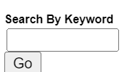Postsecondary
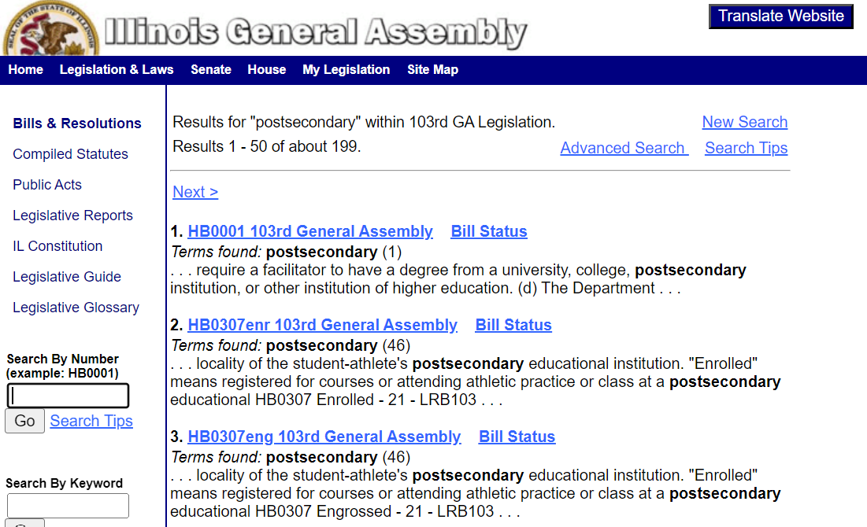

- The State Legislation Activity Form is for you to share with NASFAA any proposed, pending or recently passed legislation that could impact the financial aid community in your state, or to simply update us on percolating issues.
- The Education Commission of the States (ECS) State Education Policy Watch List is a resource to track postsecondary education bills that have been introduced at the state level. The tool allows users to search legislation by state, issue area, or bill status.
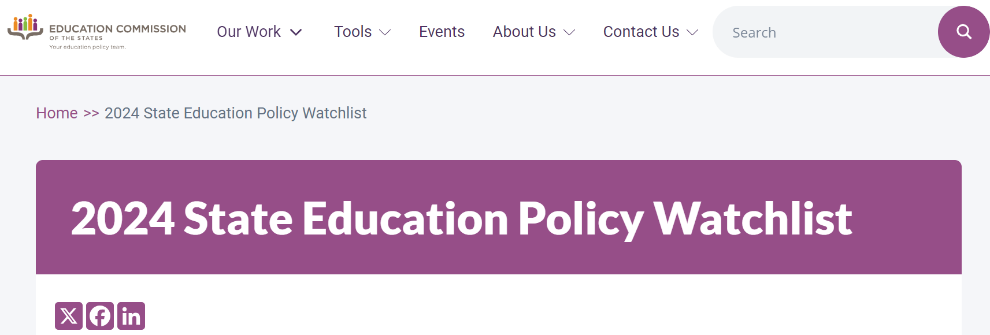
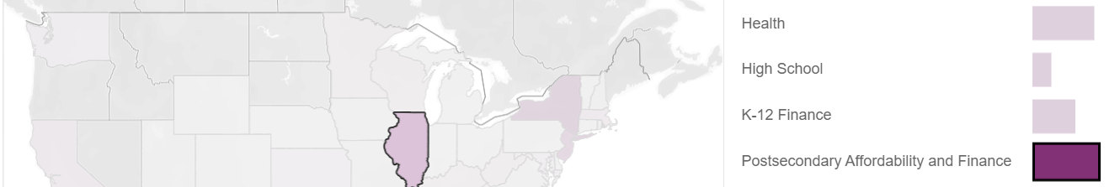
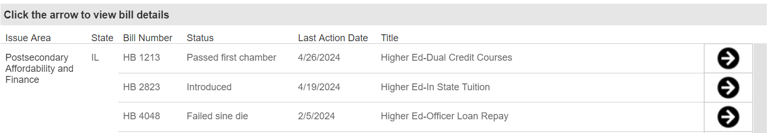

How a Bill Becomes a Law

The law of Illinois consists of several levels, including constitutional, statutory, and regulatory law, as well as case law and local law.

Illinois, like the United States legislature, has two bodies – a bicameral legislature, the Senate and the House of Representatives. A bill becomes a law when it passes both houses of the General Assembly with a majority vote in each house and is signed by the governor. This process can take time with committee debates and caucuses, hearings and amendments being incorporated. A bill that is not signed by the governor within 60 days of being presented to him or her becomes law without signature.

The governor has the power to veto a bill. If the governor vetoes a bill the legislature may override the veto by a three-fifths majority vote in each house. Laws that have passed the legislature and signed by the governor are called public laws or statutes.

A bill may be introduced in either the House or the Senate. The Illinois Constitution, Article IV, section 8, contains several requirements, which guarantee that legislators will understand the bills they are acting on before they are passed. A bill, for example, must be printed and available for reading before passage, it must address only one subject, and the section of the law that is being amended must be identified. The bill must be read on three separate days and the final vote must be recorded. Reading a bill does not mean that the entire bill is read. Usually only the title is read but the process of reading announces to the legislature that the bill is being considered, allows legislators to debate the bill and suggest amendments, and prohibits passage of a bill without at least a three-day delay.

Financial Aid 101 for Staffers

What Financial Aid Administrators Do (https://www.nasfaa.org/uploads/documents/what_FAs_do_PDF2.pdf)

For students and families:
- Know what aid is available, who qualifies for aid, how aid is equitably distributed, and the renewal requirements for subsequent years.
- Help students file applications accurately and verify their eligibility for aid Assist students on a personal level by fostering financial literacy and debt management, and by mitigating unusual circumstances that might otherwise hinder a student’s academic progress.
- Advocate for streamlining and simplifying the aid application process and for policies that ensure the federal financial aid programs are structured and implemented in a way to promote postsecondary access and success.

For the institutions they work for:
- Help enroll and retain students; many students could not attend or remain in school without financial assistance.
- Facilitate receipt of financial aid to help students meet institutional costs.
- Manage student employment; on-campus jobs help support academic departments, libraries, food service, and other facets of institutional operations Ensure compliance with voluminous and detailed federal, state, and local statute and regulations, and often coordinate campuswide compliance.
- Maintain membership and participate in professional associations, such as NASFAA, which provides opportunities for advocacy and professional development.

For their communities:
- Connect student employees with community service opportunities, literacy projects, and local businesses.
- Act as a resource for high school counselors and community based college access programs and initiatives.
- Speak at college nights or other events to explain budgeting, financial literacy, and financing an education beyond high school Serve as a resource for adults who may have an interest in attending or completing college.

For policy makers and their staff:
- Offer feedback from an institutional perspective on student aid legislation and proposals.
- Provide financial aid success stories of students from your state or district.
- Explain the financial aid needs and challenges of students in your state or district.
- Supply statistics detailing the amount of aid that benefits students from your state or district.
- Illustrate how compliance with certain existing and proposed statutes can hinder opportunities to assist and counsel students.

Financial aid administrators are a great source of information to find out how policies are directly affecting the college students in your district. These professionals are working directly with students and have a unique perspective on the issues facing their students both on and off campus.
Responding to Legislation

State Laws and Regulations
State legislatures make the laws in each state. State courts can review these laws. If a court decides a law does not agree with the state's constitution, it can declare it invalid. Find state laws and regulations with the Law Library of Congress’s guide for each state.
Illinois: https://guides.loc.gov/law-us-illinois

The Board of Higher Education monitors legislation affecting colleges and universities and their students, proposes legislative initiatives to advance Board priorities, and addresses issues raised by members of the General Assembly. There are many ways to communicate with your elected official – from letters – to phone calls – to in-person visits. Find your Legislator
Writing Letters
When writing letters, make sure that your writing is clear and precise. Include your name and address. Follow one of these standard ways for addressing your legislator:
For letters to State Senators:
The Honorable (First Name, Last Name)
Illinois State Senate
Statehouse
Springfield IL 62706
Dear Senator:
For letters to State Representatives:
The Honorable (First Name, Last Name)
Illinois House of Representatives
Statehouse
Springfield, IL 62706
Dear Representative:
For letters to Members of Congress:
The Honorable (First Name, Last Name)
U.S. House of Representatives
Street Address
Washington, D.C.
Or
The Honorable (First Name, Last Name)
U.S. Senate
Street Address
Washington, D.C.
For specific addresses, call 202-225-7000 or go to the United States Congress Web site at
www.house.gov or www.senate.gov.

Phone Calls
A phone call can be a very fast, immediate way to communicate your position on an issue – or to find out your legislator’s position.
Contact the State of Illinois at 217-782-2000 or 312-814-3500 to get specific numbers for members of the General Assembly or link to www.ilga.gov.
For members of the U.S. Congress, call 202-224-3121 or link to http://thomas.loc.gov.
In-Person Meetings
To schedule a meeting with your legislator, call his or her office to speak with a staff member. Identify yourself as a constituent, and indicate the issue you would like to discuss. In-person meetings are particularly effective if you are impacted by a particular piece of legislation.
Legislative Testimony at the General Assembly
Legislative hearings are held throughout the legislative process during the committee phase. To find out if a bill has been scheduled for a hearing, call the Legislative Information Service at 217-782-3944 or go to www.ilga.gov.

Advocating through Negotiated Rulemaking
Negotiated Rulemaking (or “Neg Reg”) is a process used by the U.S. Department of Education and other federal agencies, in which representatives from a government agency and affected interest groups negotiate the terms of a proposed administrative rule. The agency publishes the proposed rule in the Federal Register and then follows the usual rulemaking procedure of soliciting public comments, which are evaluated for inclusion in the final rule.
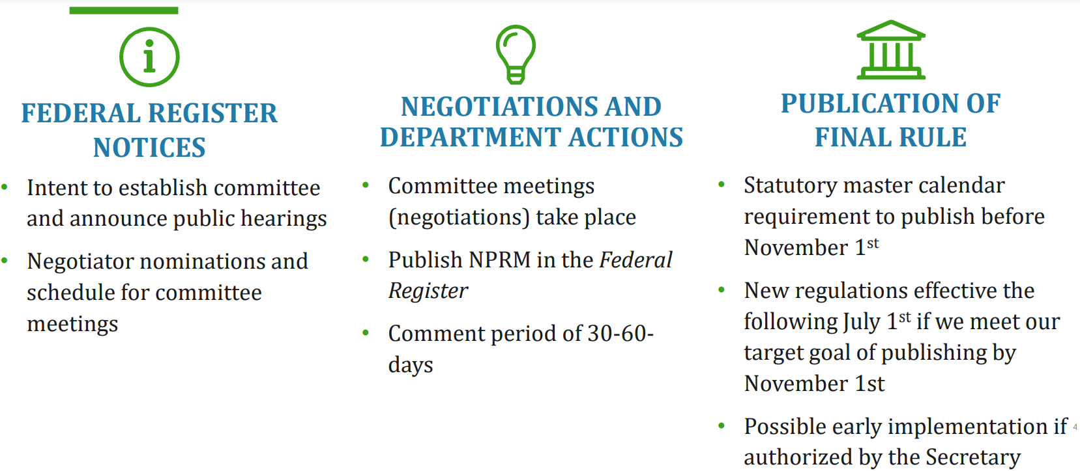
Participating as a Primary or Alternate Negotiator
- Nominations for negotiators and contact information must be emailed to negregnominations@ed.gov
- Individuals selected must have demonstrated expertise or experience in the relevant topics proposed for negotiations
- The Department strongly encourages nominees to list all constituencies under which they would like to be considered.
- A primary and alternate negotiator represents each constituency: The primary negotiator participates for the purpose of determining consensus and the alternate participates for the purpose of determining consensus in the absence of the primary negotiator.
- Dates and times of the committee meetings are set out in the Schedule for Negotiations
- All meetings are virtual
Participating in Public Comment
- 30–60-day comment period
- Submit online at regulations.gov
- Please do not submit the same comment online and by mail
- Consider reviewing others’ submitted comments
- Tip: Co-sign a comment instead of sending the same comment separately

Resources

AACROA Advocacy Center
https://www.aacrao.org/advocacy

Capitol Fax
https://capitolfax.com/

Education Commission of the States (ECS) State Education Policy Watch List
https://www.ecs.org/state-education-policy-watch-list/

Hannah News Service
https://hannah-il.com/Login/Index.html

NASFAA State Advocacy Toolkit
https://www.nasfaa.org/state_advocacy_toolkit

Negotiated Rulemaking Status
https://www.ed.gov/laws-and-policy/higher-education-laws-and-policy/negotiated-rulemaking-process-title-iv-regulations

Process Diagram of Illinois Bill Becoming a Law
https://www.ilga.gov/commission/lis/98bill_law.pdf

CEE-(Note need to add the Legislative calendar, examples of how to letters/phone calls)
CEE-(Need to add the NCAN toolkit to the LTK folder as a reference also)
CEE- add a flow chart
CEE- how to find your representative

JMA – NCAN Link --Advocacy How-To Resources - National College Access Network

AJS – Information on how to identify if your university has a legislative liaison

